SEC : A IPC-1: PIPE, FIFO BATCH : A3

REG: 190905513 LAB 05 NAME: MOHAMMAD DANISH EQBAL

LAB EXERCISES:

1. Write a producer and consumer program in C using the FIFO queue. The producer should write a set of 4 integers into the FIFO queue and the consumer should display the 4 integers.

Program:

//Producer
#include<stdio.h>
#include<stdlib.h>
#include<unistd.h>
#include<sys/types.h>
#include<limits.h>
#include<fcntl.h>
#include<sys/msg.h>
#include<sys/stat.h>
#include<string.h>

#define FIFO_NAME "my_fifo"
#define BUFFER_SIZE 1000

int main(int argc, char *argv[])
{
int pipe_fd;
int res;
int open_mode=O_WRONLY;
int n=0;
char buffer[BUFFER_SIZE+1];

if(access(FIFO_NAME,F_OK)==-1)
{
res=mkfifo(FIFO_NAME,0777);
if(res!=0)
{
fprintf(stderr, "Could not create file%s\n",FIFO_NAME );
exit(EXIT_FAILURE);
}
}

printf("Process %d opening FIFO O_WRONLY\n",getpid());
pipe_fd=open(FIFO_NAME,open_mode);
printf("Process %d result %d\n",getpid(),pipe_fd);

if (pipe_fd!=-1)
{
printf("Enter 4 numbers\n");

while(n<4)
{
scanf("%s",buffer);
res=write(pipe_fd,buffer,BUFFER_SIZE);

if(res==-1)
{
fprintf(stderr, "Write Error on Pipe\n");
exit(EXIT_FAILURE);
}
n++;
}
(void)close(pipe_fd);
}
else
exit(EXIT_FAILURE);

printf("Process %d Finished\n",getpid() );
exit(EXIT_SUCCESS);

}

//Consumer
#include<stdio.h>
#include<stdlib.h>
#include<unistd.h>
#include<sys/types.h>
#include<limits.h>
#include<fcntl.h>
#include<sys/msg.h>
#include<sys/stat.h>
#include<string.h>

#define FIFO_NAME "my_fifo"
#define BUFFER_SIZE 1000

int main(int argc, char *argv[])
{
int pipe_fd;
int res;
int open_mode=O_RDONLY;
int n=0;
char buffer[BUFFER_SIZE+1];
memset(buffer,'\0',sizeof(buffer));

printf("Process %d opening FIFO O_RDONLY\n",getpid());
pipe_fd=open(FIFO_NAME,open_mode);
printf("Process %d result %d\n",getpid(),pipe_fd);

if (pipe_fd!=-1)
{
do
{
res=read(pipe_fd,buffer,BUFFER_SIZE);
printf("%s\n",buffer );
n++;
}while(n<4);

(void)close(pipe_fd);
}

else
exit(EXIT_FAILURE);

printf("Process %d Finished, %d bytes read\n",getpid(),n );
exit(EXIT_SUCCESS);
}

Output:
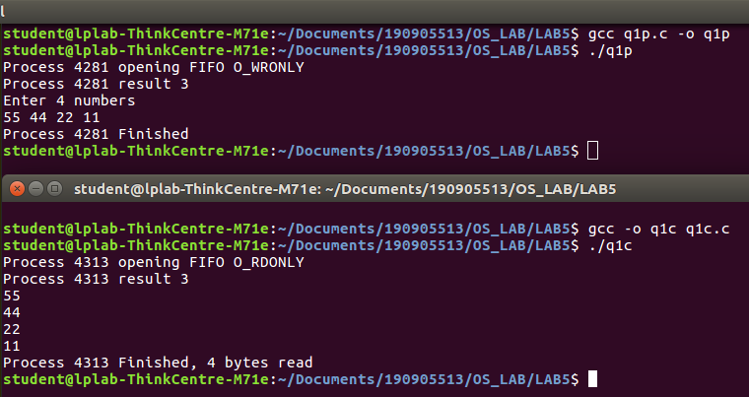

2. Demostrate creation, writing to, and reading from a pipe.

Program:

#include<stdio.h>
#include<stdlib.h>
#include<unistd.h>
#include<sys/types.h>
#include<sys/ipc.h>
#include<sys/msg.h>
#include<string.h>

int main(int argc, char *argv[])
{
int n;
int fd[2];
char buf[1025];
char *data="190905513 MOHAMMAD DANISH EQBAL B.TECH LATERAL ENTRY!";
pipe(fd);
write(fd[1],data,strlen(data));

if(n=read(fd[0],buf,1024)>=0)
{
buf[n]=0;
printf("Read %d bytes from pipe\"%s\"\n",n,buf);
}

else
perror("Read");
exit(0);
}

Output:
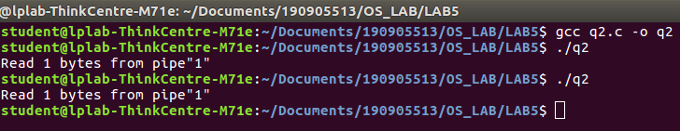

3. Write a C program to implement one side of FIFO.

Program:

//1st User
#include<stdio.h>
#include<stdlib.h>
#include<unistd.h>
#include<sys/types.h>
#include<limits.h>
#include<fcntl.h>
#include<sys/msg.h>
#include<sys/stat.h>
#include<string.h>

#define FIFO_NAME "my_fifo"
#define BUFFER_SIZE 10000

int main(int argc, char *argv[])
{
int pipe_fd;
int res;
int open_mode1=O_WRONLY;
int open_mode2=O_RDONLY;
int n=0;
char buffer[BUFFER_SIZE+1];

if(access(FIFO_NAME,F_OK)==-1)
{
res=mkfifo(FIFO_NAME,0777);

if(res!=0)
{
fprintf(stderr, "Could not create file%s\n",FIFO_NAME);
exit(EXIT_FAILURE);
}
}

printf("You can start chatting with 2nd User now\n");

while(1)
{
pipe_fd=open(FIFO_NAME,open_mode2);

printf("\nText from 1st User: ");
res=read(pipe_fd,buffer,BUFFER_SIZE);
printf("%s\n",buffer );
close(pipe_fd);

printf("Wait for 1st User reply\n");
pipe_fd=open(FIFO_NAME,open_mode1);

printf("\nEnter Text to send to 1st User: ");
fgets(buffer,BUFFER_SIZE,stdin);
res=write(pipe_fd,buffer,BUFFER_SIZE);

close(pipe_fd);

}

(void)close(pipe_fd);

printf("Process %d Finished\n",getpid());
exit(EXIT_SUCCESS);
}

//2nd User
#include<stdio.h>
#include<stdlib.h>
#include<unistd.h>
#include<sys/types.h>
#include<limits.h>
#include<fcntl.h>
#include<sys/msg.h>
#include<sys/stat.h>
#include<string.h>
#define FIFO_NAME "my_fifo"
#define BUFFER_SIZE 10000

int main(int argc, char *argv[])
{
int pipe_fd;
int res;
int open_mode1=O_WRONLY;
int open_mode2=O_RDONLY;
int n=0;
char buffer[BUFFER_SIZE+1];

if(access(FIFO_NAME,F_OK)==-1)
{
res=mkfifo(FIFO_NAME,0777);
if(res!=0)
{
fprintf(stderr, "Could not create file%s\n",FIFO_NAME );
exit(EXIT_FAILURE);
}
}

printf("You can start chatting with 2nd User now\n");

while(1)
{
pipe_fd=open(FIFO_NAME,open_mode1);
printf("\nEnter Text to send to 2nd User: ");
fgets(buffer,BUFFER_SIZE,stdin);
res=write(pipe_fd,buffer,BUFFER_SIZE);

close(pipe_fd);

printf("Wait for 2nd User’s reply\n");
pipe_fd=open(FIFO_NAME,open_mode2);

printf("\nText from 2nd User: ");
res=read(pipe_fd,buffer,BUFFER_SIZE);
printf("%s\n",buffer );
close(pipe_fd);

}
(void)close(pipe_fd);

printf("Process %d Finished\n",getpid() );
exit(EXIT_SUCCESS);
}

Output:

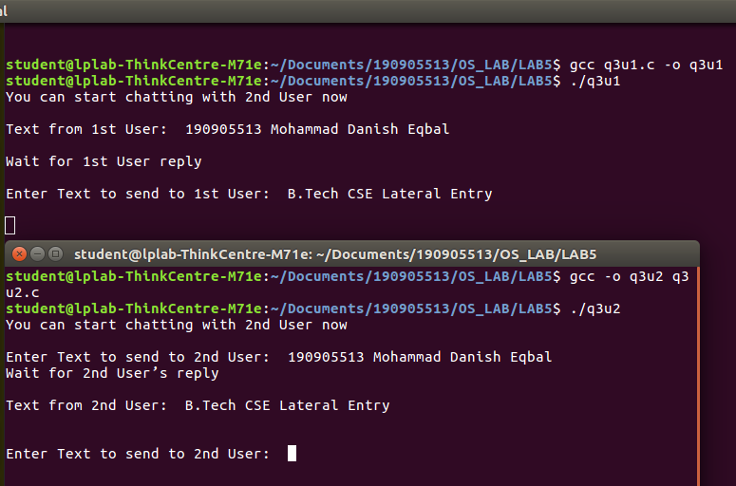

4. Write a C program reading and writing a binary files in C.

Program:

#include<stdio.h>
#include<stdlib.h>

int main()
{

FILE* fptr;
int num=0;
fptr=fopen("demo.bin","wb+");

printf("Enter 7 numbers : \n");

for(int i=0;i<7;i++)
{

scanf("%d",&num);
fwrite(&num,sizeof(int),1,fptr);
}

printf("Writing done!\n");
fclose(fptr);

fptr=fopen("demo.bin","rb");

for(int i=0;i<7;i++)
{

fread(&num,sizeof(int),1,fptr);
printf("%d\n",num);
}

}

Output:
